**DEPARTMENT OF COMPUTER SCIENCE-UBIT**



***“GESTURE CONTROL ROBOT CAR”***

PREPARED BY

**SHEHARYAR-(B16101146)**

**MUHAMMAD HAMZA-(B16101093)**

**SYED TAHA HASAN-(B16101175)**

**MUHAMMAD HASEEB KHAN-(B16101095)**

**SALMAN AYUB-(B16101110)**

SUBMITTED TO:

SIR BADAR SAMI

**Contents**

**ABSTRACT** 3

**INTRODUCTION** 3

**APPLICATIONS** 4

**COMPONENTS AND SUPPLIES** 4

**WORKING** 9

**RECIEVER CIRCUIT** 10

**TRANSMITTING CIRCUIT** 11

**WHAT GESTURE WILL THE ROBOT RECOGNIZE?** 12

**CONCLUSION:** 14

# **ABSTRACT**

Gesture Controlled Robot is a robot which can be controlled by simple gestures. The user just needs to wear a gesture device which includes a sensor. The sensor will record the movement of the robot in the respective direction. The robot and the Gesture device are connected wirelessly via radio waves. The wireless communication enables the user to interact with the robot in a friendlier way.

# **INTRODUCTION**

I wish I could control everything with my hands! Sitting in my chair and controlling things like a BOSS. I'd love it! So I finally came out with a cool Hand gesture recognition robot, which can follow the commands made by hand gestures. Sounds crazy but I promise it’s very simple. Making a gesture control robot is actually very simple.

The robot is divided into two parts, transmitter and receiver.

I will be using an Arduino as the programming platform. To recognize the gestures made I will be using an accelerometer sensor. So let’s get building!

# **APPLICATIONS**

* Through the use of gesture recognition, remote control with the wave of a hand of various device is possible.
* Gesture controlling is very helpful for handicapped and physically disabled people to achieve certain tasks, such as driving a vehicle.
* Gesture can be used to control interaction for entertainment purposes such as gaming to make the game player’s experience more interactive or immersive
* Military applications
* Useful for moving heavy leads from one place to another.

# **COMPONENTS AND SUPPLIES**

1. **Arduino Lily-pad**

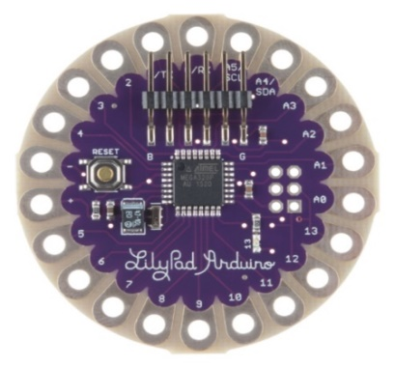

1. **Accelerometer**

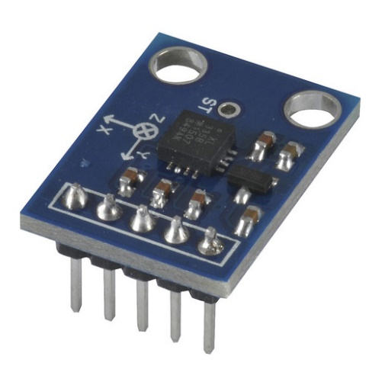

1. **RF 433 Module**

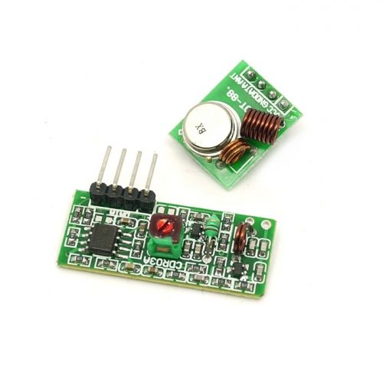

1. **HT12E and HT12D**

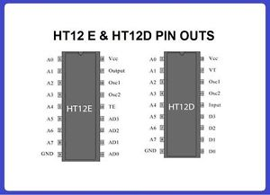

1. **Motor driver L293DNE**

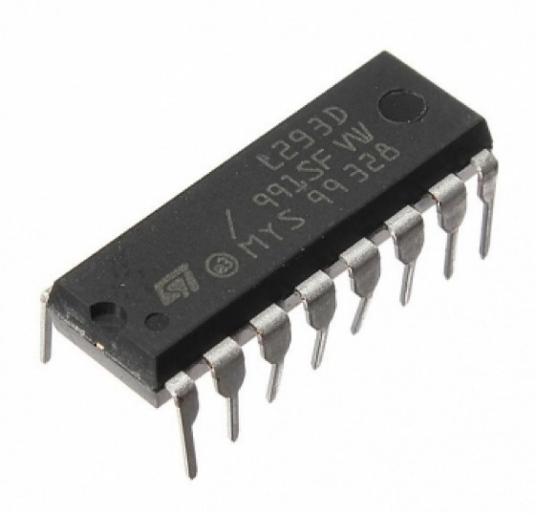

1. **BO Motor and Wheels**

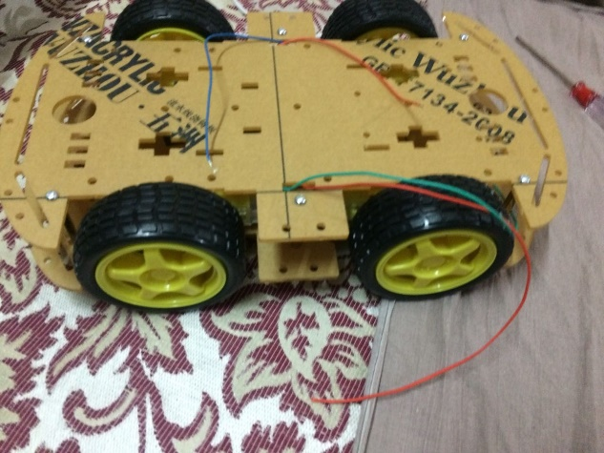

1. **Prototyping Board**

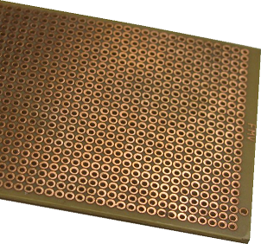

1. **Battery**



1. **7805**

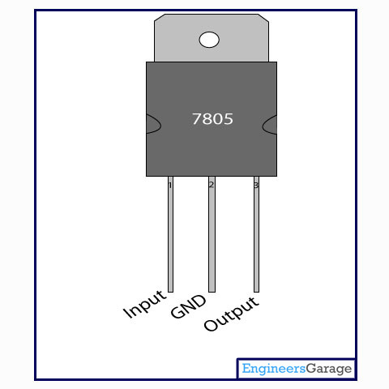

1. **jumper**

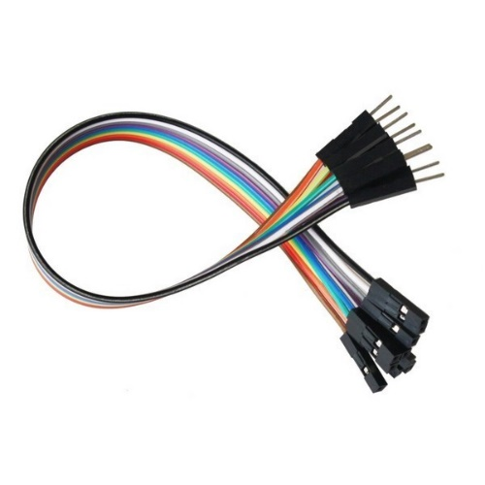

# **WORKING**

**How does it work and recognize the gestures?**

Here the brain of the robot is Arduino Lily-pad (Atmega32) it is fed with some set of code. The gestures/motion made by hand are recognized by an acceleration measuring device called accelerometer (ADXL335).

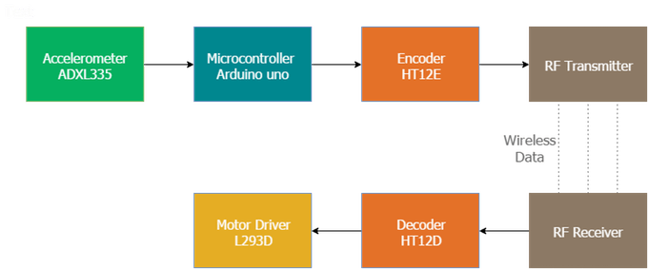

Here the accelerometer reads the X Y Z coordinates when we make gestures by hand and send the X Y Z coordinates to the Arduino (here we don’t need the Z axis we need only two coordinated X and Y So neglect the Z coordinate). The Arduino checks the values of coordinates and sends a 4 bit code to the Encoder IC. The Encoder passes the data to RF transmitter and the transmitted data is received by the RF receiver. The receiver sends the 4-bit code to the Decoder IC and the decoder passes it to Motor Driver IC. Later the motor driver makes the decision to turn the two motors in the required direction.

# **RECIEVER CIRCUIT**

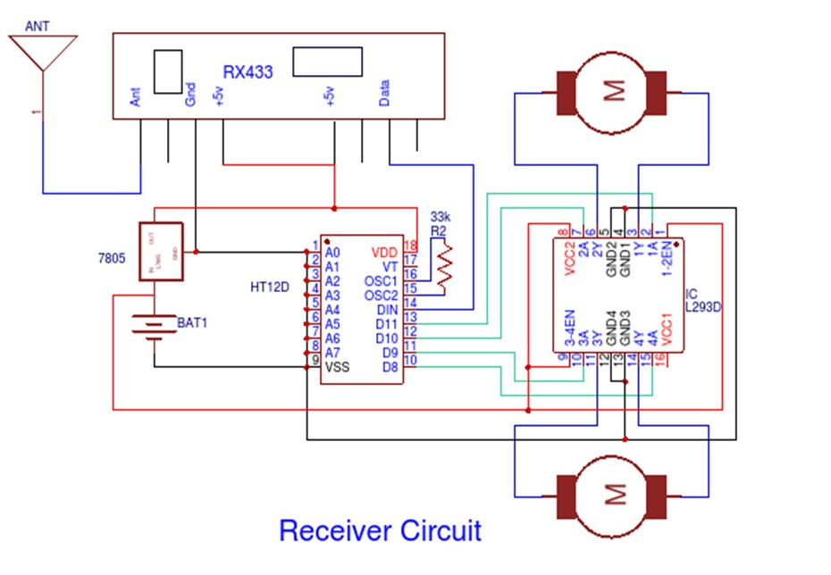

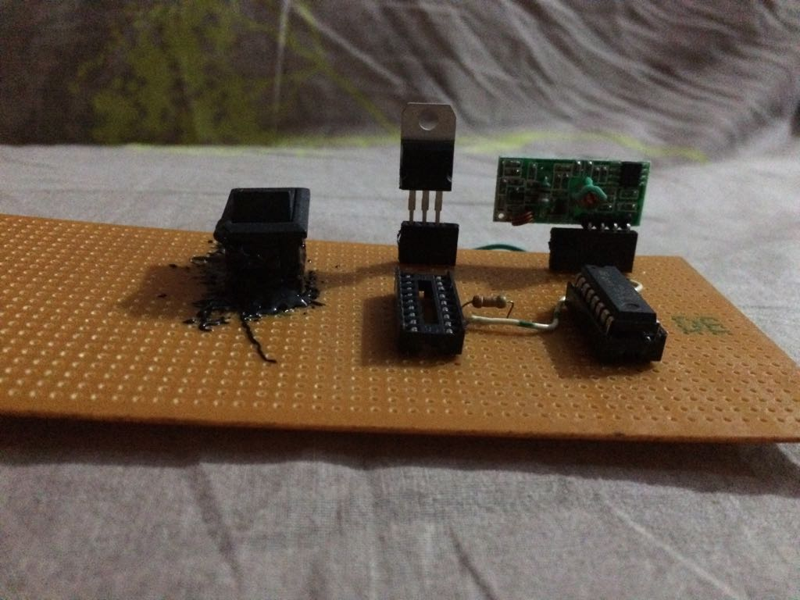

# **TRANSMITTING CIRCUIT**

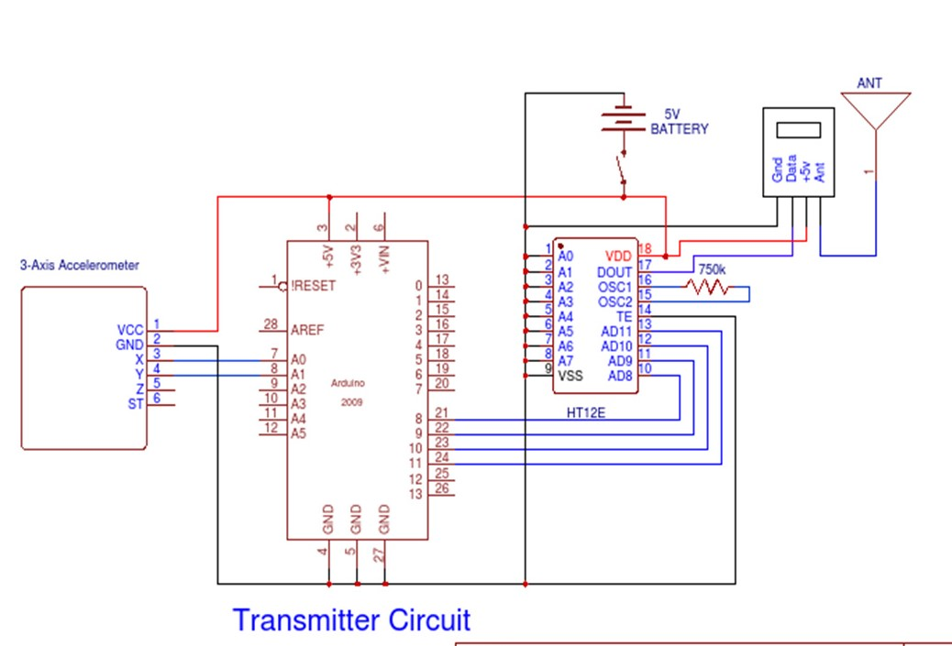

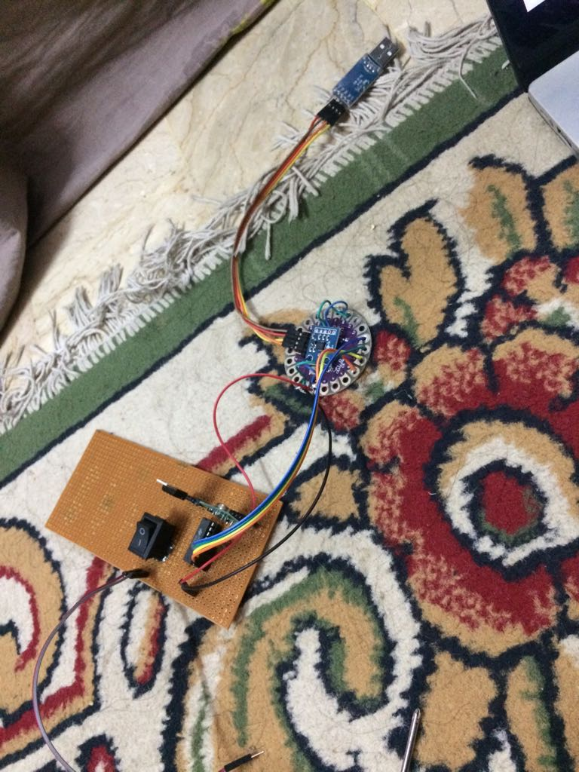

# **WHAT GESTURE WILL THE ROBOT RECOGNIZE?**

This robot is designed for recognizing five sets of gestures: forward, backward, left, right and stop. You will get a better idea if you check the photos of the gestures given below.

[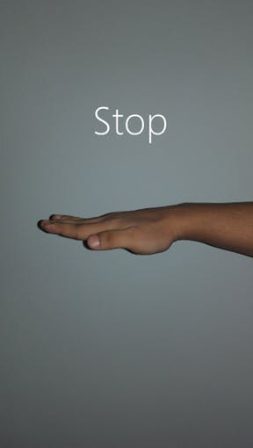](javascript:openLightBox('1fb0ba8b29',%200);)

Stop_flat

[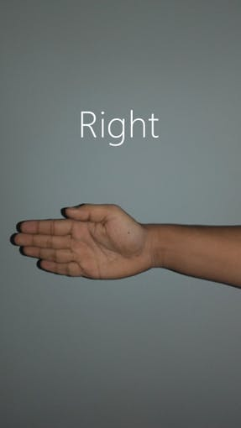](javascript:openLightBox('dccedcf550',%200);)0

right_flat

[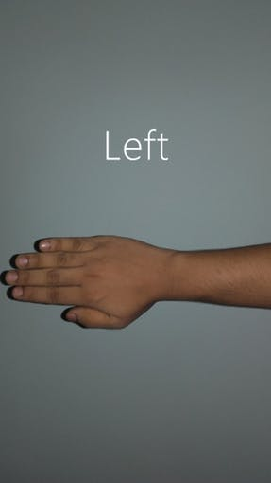](javascript:openLightBox('8d4b4005a2',%200);)

left_flat

[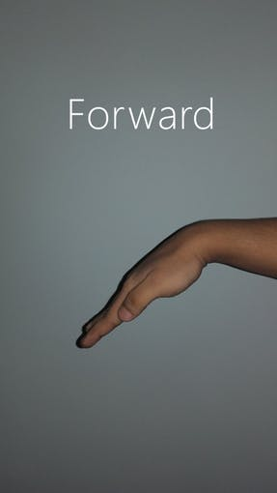](javascript:openLightBox('2006bfc7e5',%200);)

forward_flat

[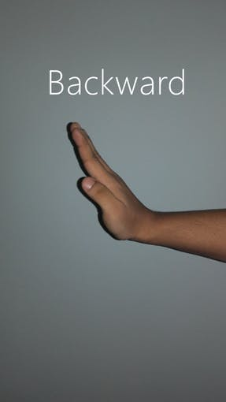](javascript:openLightBox('9e7f06e33d',%200);)

backward_flat

# **CONCLUSION:**

In this proposed work, Gesture Control Robot is successfully developed and implemented in real time environment. This system is developed at low cost, low power and time. The system provides better performance in the experimental setup. Adding more accessories to the mobile robot and controlling it using Gesture is also possible.

The Gesture Controlled Robot system gives an alternative way of controlling robots. Gesture control being a more natural way of controlling devices makes control of robots more efficient and easy